Chapter 17, Problem 80.

Write a computer program to calculate the exponential Fourier series of the half-wave rectified sinusoidal current of Fig. 17.82. Consider terms up to the 10th harmonic.

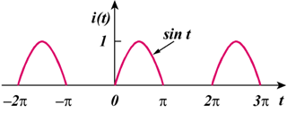

Figure 17.82
For Prob. 17.80.

